EXPERIMENT – 4

EXP NO 3: CREATE A SIMPLE CLOUD SOFTWARE APPLICATION FOR SMART CAR BOOKING USING ANY CLOUD SERVICE PROVIDER TO DEMONSTRATE SAAS.
DATE:3/11/25
AIM:
To Create a simple cloud software application for Smart Car Booking
using any Cloud Service Provider to demonstrate SaaS.
PROCEDURE:
step1: Go to zoho.com.
step 2: Log into the zoho.com.
step 3: Select one application step.
step4: Enter application name as Smart Car Booking.
step 5: Created new application Smart Car Booking.
step 6: Select one form
step 7: The software has been created.
OUTPUT:
FORM 1 –Car Details Form

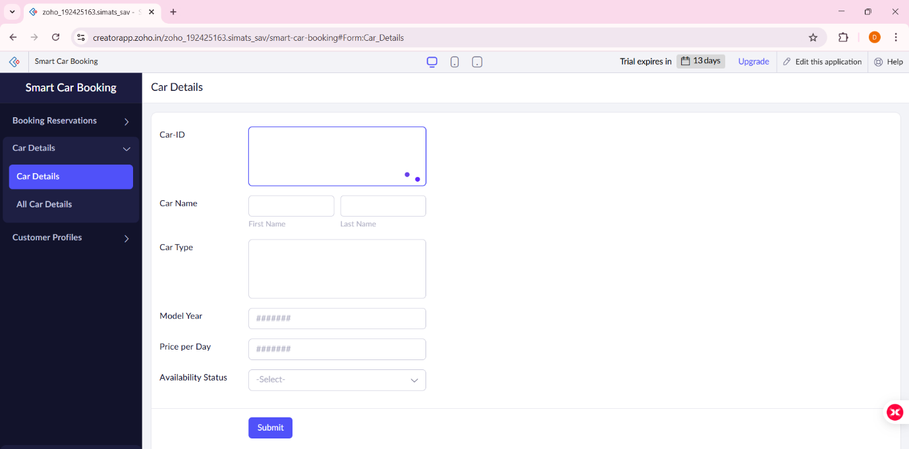
FORM 2 –Customer Profile Form

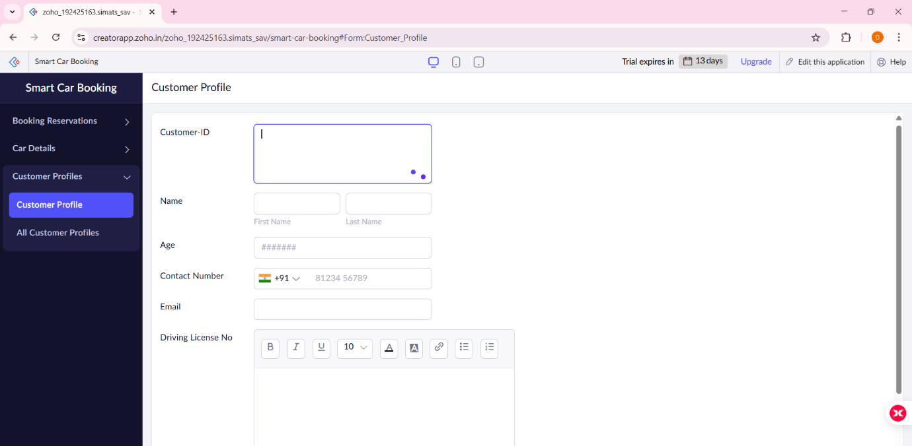

FORM 3 –Booking Reservation Form

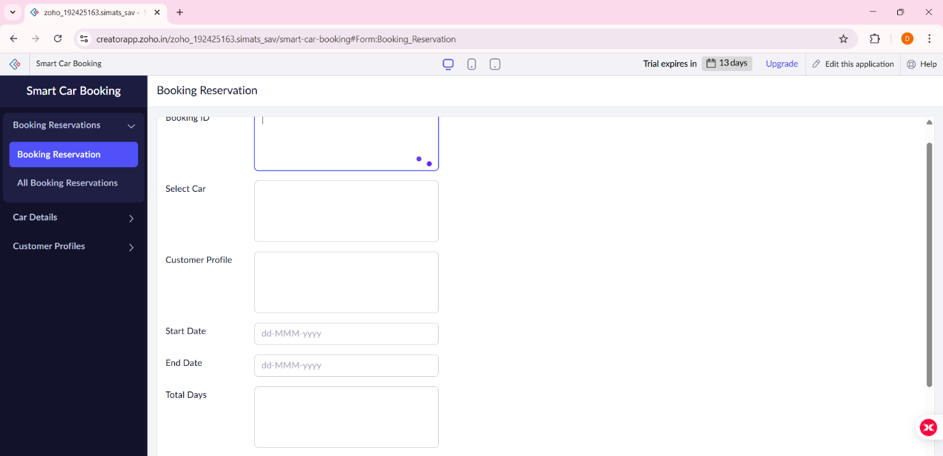

FORM 1 – Car Details Form

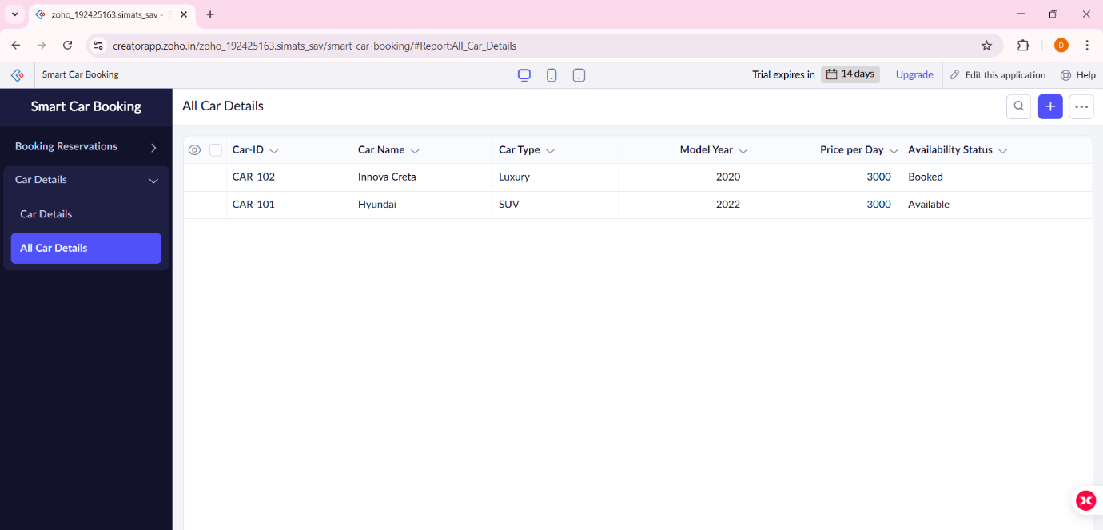

FORM 2 –Customer Profile Form

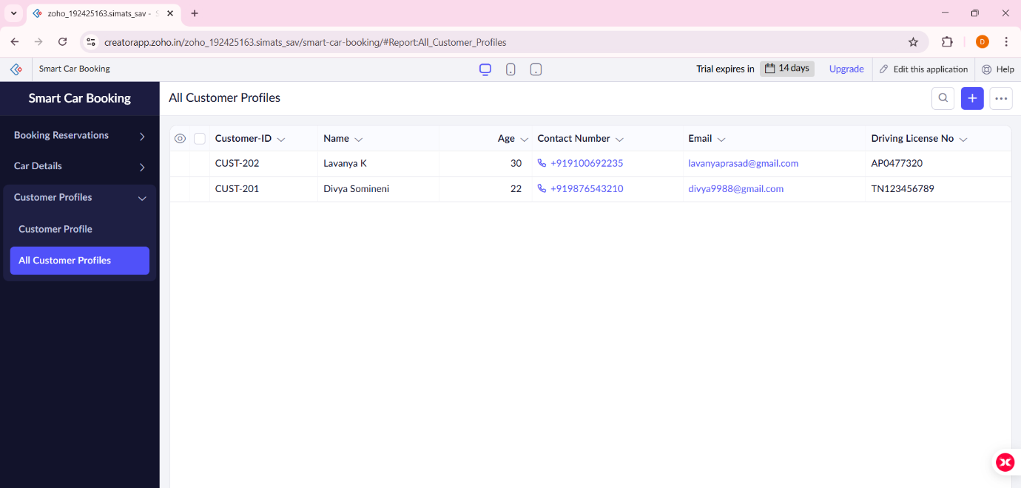

FORM 3 –Booking Reservation Form

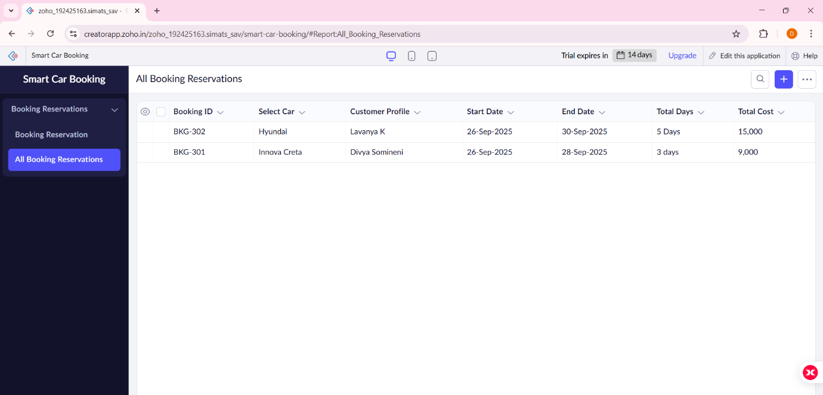

RESULT:
The Smart Car Booking application was successfully created using Zoho Creator (Cloud SaaS platform) with the following forms:
- Car_Master
- Customer_Profile
- Booking_Reservation
This demonstrates SaaS, as customers can register, view available cars, make bookings, and check their booking status entirely online without installing any software.

